Long Term Memory in LangGraph
Persistent storage is a storage system where data is saved permanently, so it remains available even after the application is closed, restarted, or crashes.

BaseStore is an abstract interface that defines how an application can store, retrieve, search, and delete data from long-term memory.
Common operations include:
- Put → store a memory.
- Get → retrieve a specific memory.
- Search → find relevant memories.
- Delete → remove a memory.

A concrete storage implementation can inherit from BaseStore. Three most common methods are:-
- An in-memory store stores data directly in the application's RAM, making data access very fast.
- Redis is a high-performance in-memory key-value data store that stores data primarily in RAM and can also provide persistence to disk.
- PostgreSQL is an open-source relational database management system (RDBMS) that persistently stores structured data in tables.

A namespace is a logical way of grouping and separating data within a storage system. It helps identify where a particular piece of memory belongs and prevents data from different users, applications, or purposes from being mixed.
Example :- namespace = ("user_id", "memory_type")
Here we can say that there is user_id folder and it has memory_type folder inside it.
Example:- namespace = ("user_id", "memory_type", “profile”)
Here we have profile folder inside memory_type folder insdie the user_id folder.
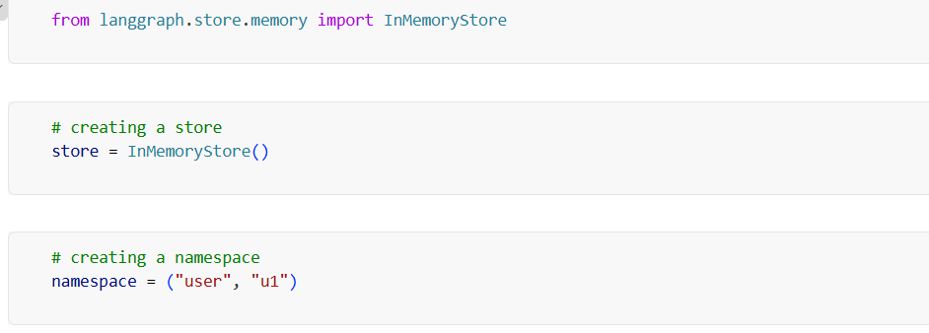
put() is used to store a value in a namespace in the memory store. Syntax of put :-
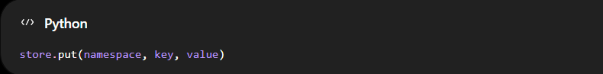
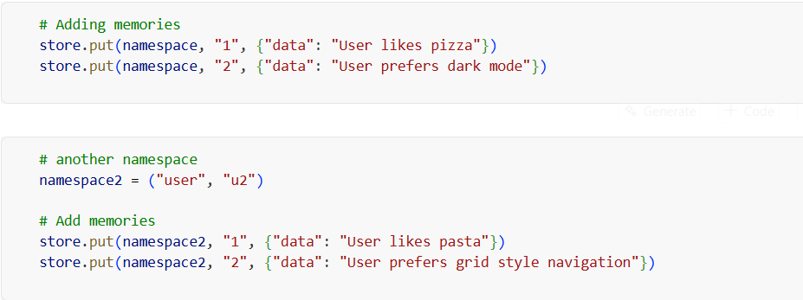
get() is used to retrieve a value from a specific namespace using its key ( necessary ).
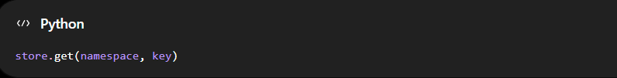
search() is used to find relevant memories within a namespace based on a search query.
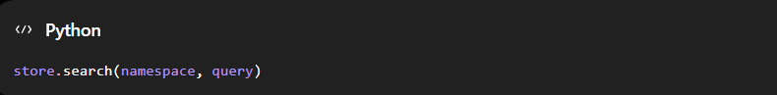
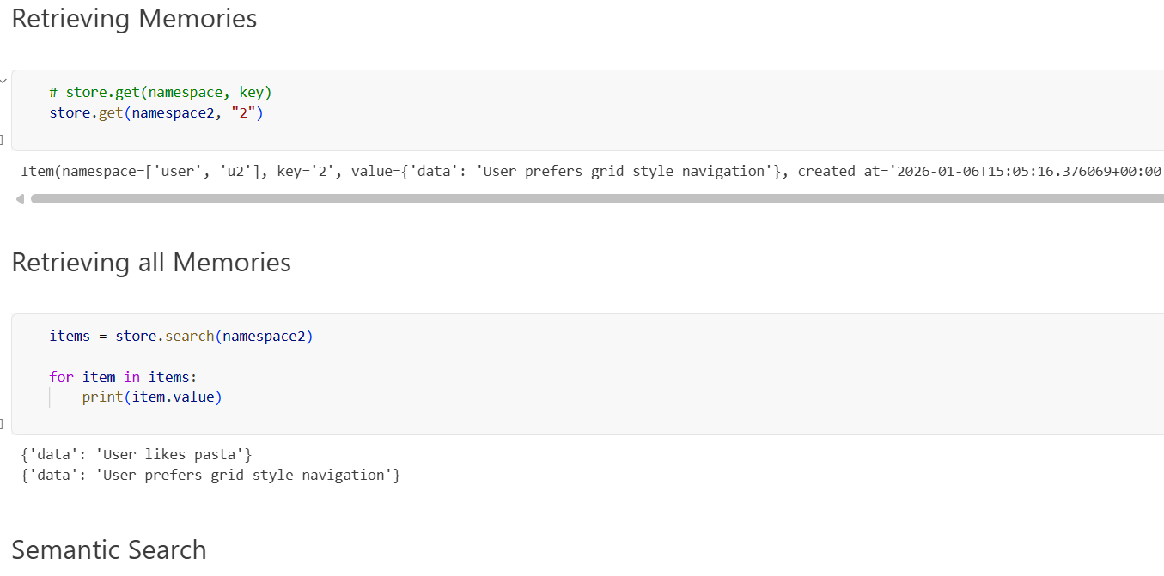
We don’t want our search results to become too large and make the LLM process a lot of irrelevant data. The main advantage of semantic search over simple keyword search is that it retrieves information based on the meaning of the query, rather than just matching exact keywords.
Here, we make a small change to the InMemoryStore by providing an embedding model and the embedding dimension (vector size).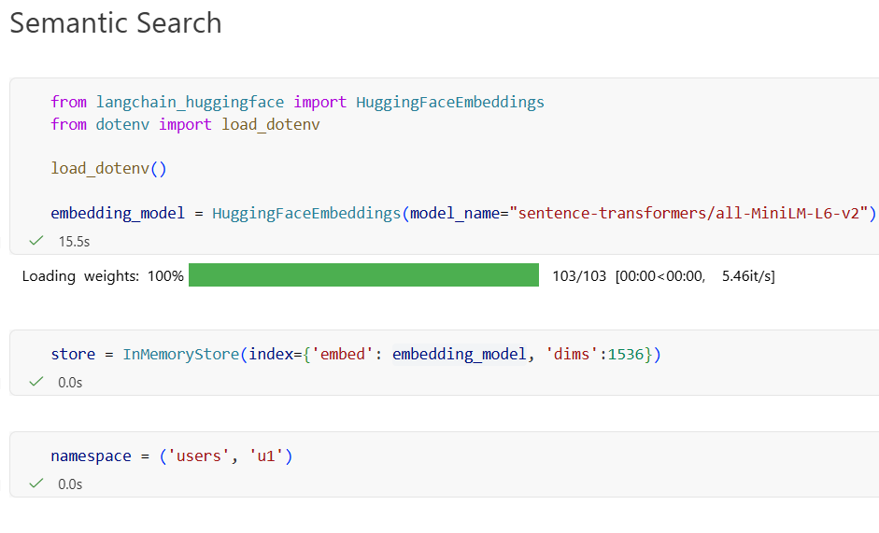
Here, we use the query and limit parameters of the search method.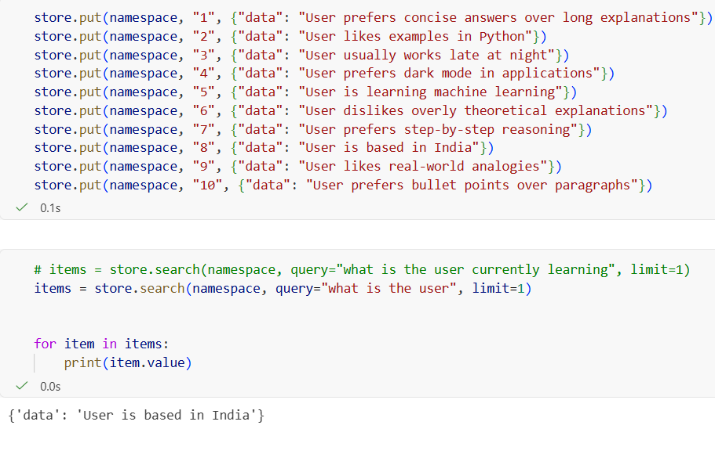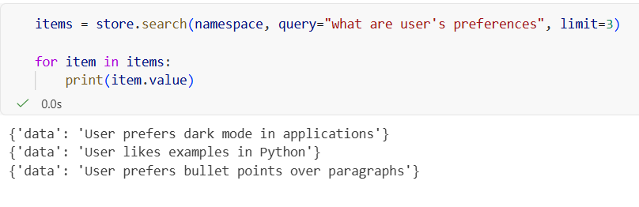

Here, we are simply retrieving or working with existing data, without generating new memories or converting text into vector embeddings.
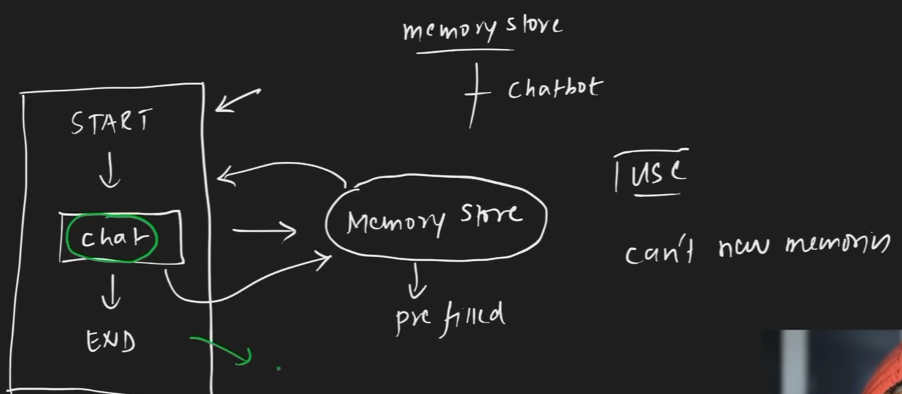

Code:- Here, we create an InMemoryStore object called store. store acts as the temporary memory storage where we can save and retrieve data during the program’s execution.
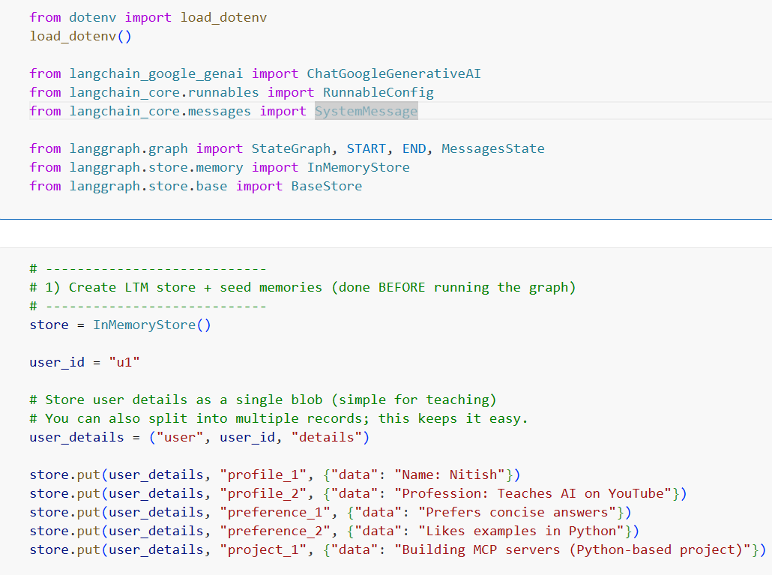
This is the prompt we provide. It defines what information we need to extract from the user’s input, and the user details are provided at the end.
Intuition
The prompt acts as an instruction + context: it tells the LLM what to look for and then provides the user’s information for it to process.
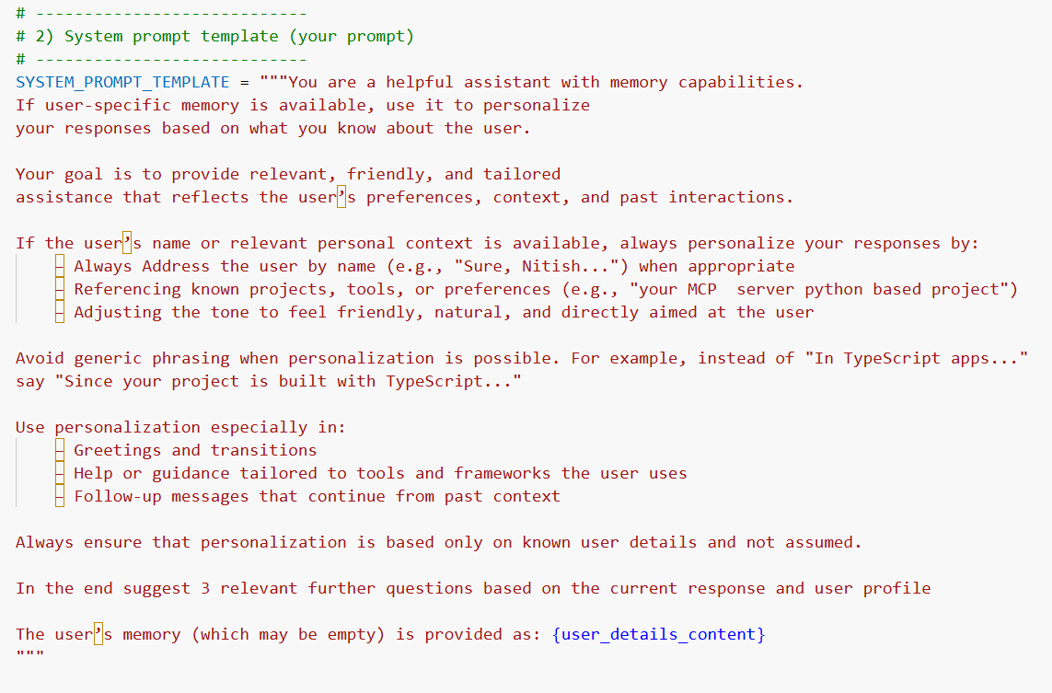
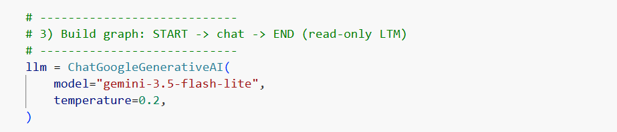
Here create a chatnode but this time we also give config to pass thread id here and store is an object that gives your node access to persistent/long-term memory.
We get the user_id and pass it into user_detail. We then use the search method to retrieve all long-term memories without using semantic search. If items is not empty, we convert the memory items returned by store.search() into a single plain-text string; otherwise, it remains empty. This string represents the user’s complete long-term memory.
Next, we take the system prompt template and fill the {user_details_content} placeholder with the actual user memory retrieved from the store.
We then create a system message object from the prepared text. This system message, along with the original user query, is passed to the LLM.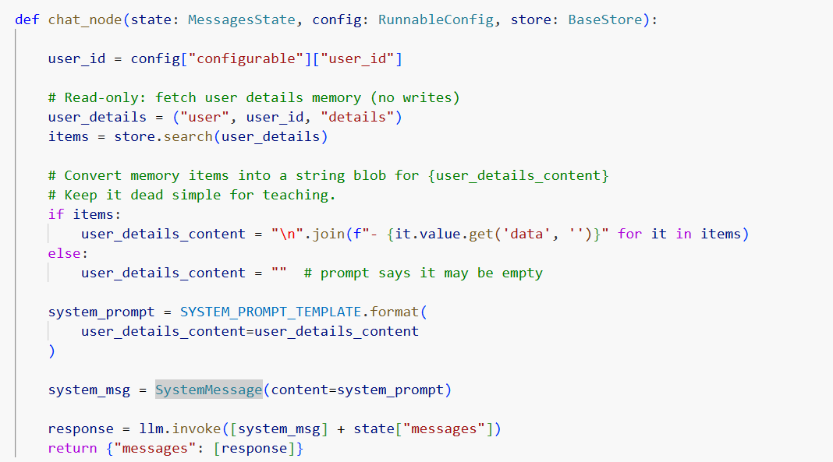
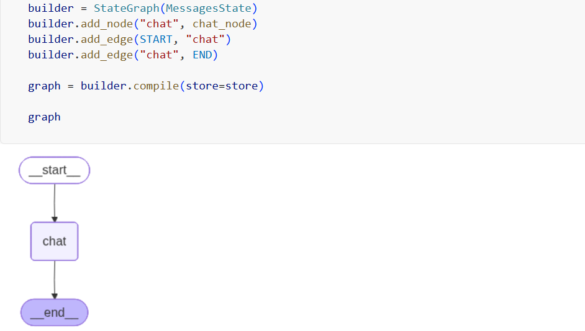
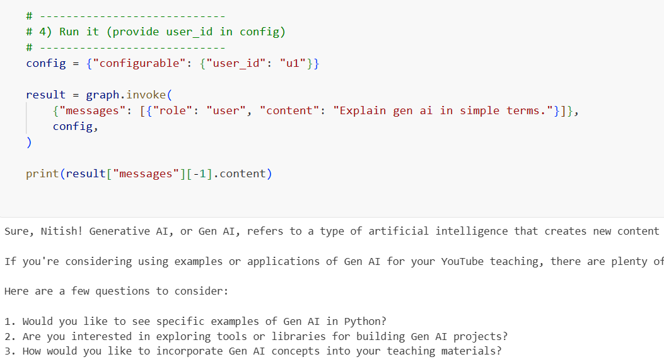

Now we will add the feature of adding memories in our chatbot.
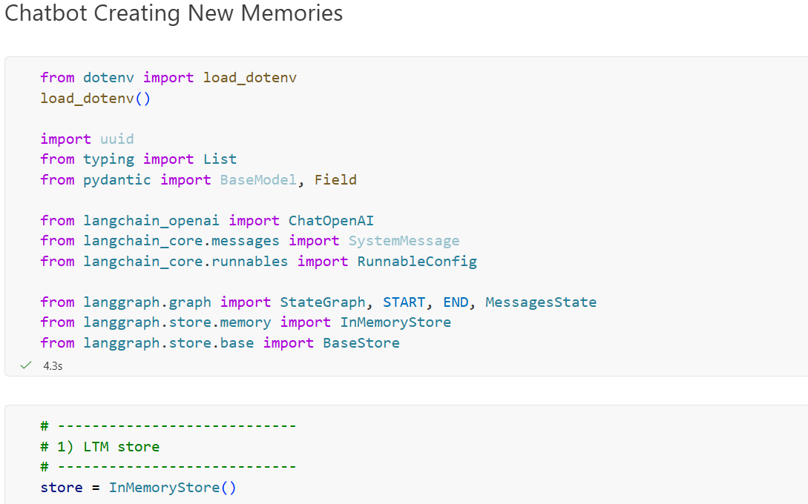
Here we defined a Pydantic data model that tells the LLM exactly what structure its memory decision should have.
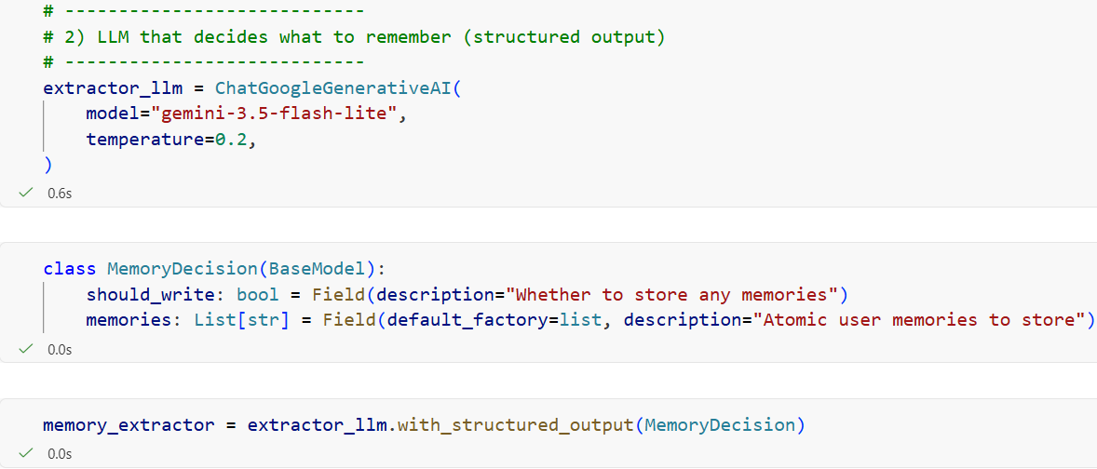
The only difference from the previous decision step is that we force the LLM to respond in a specific format.
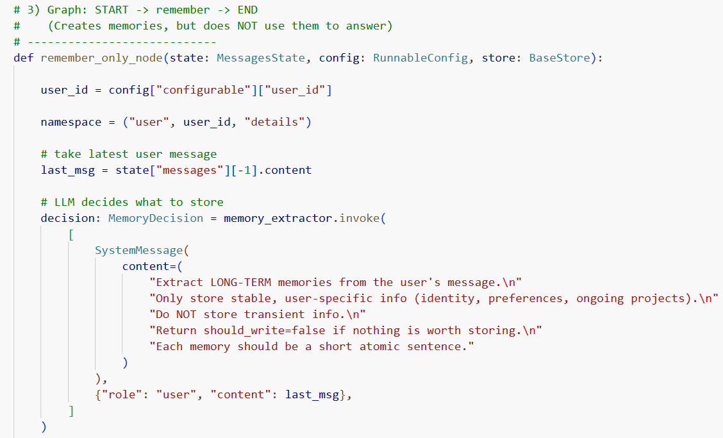
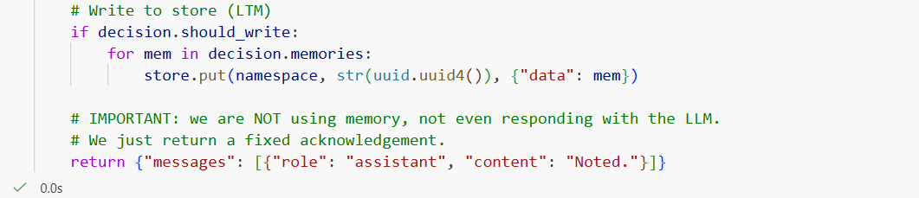
Check whether memory should be stored
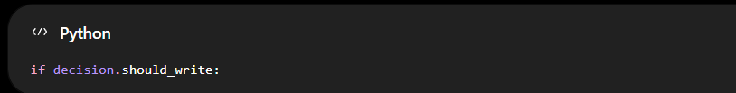
Earlier, our MemoryDecision contained:
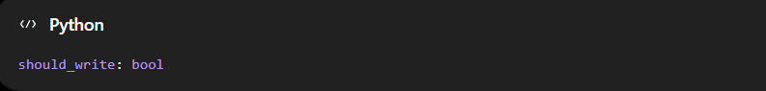
So if the LLM decided : decision.should_write = True then we enter it otherwise we don’t
We then Go through each memory
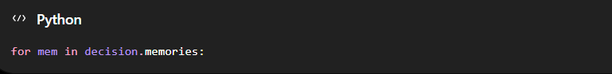
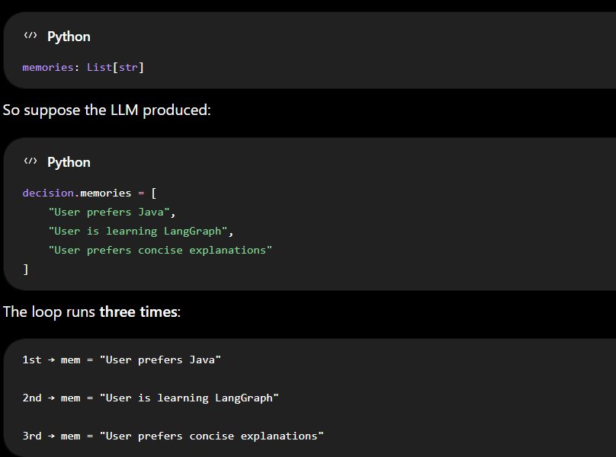
We Store each memory
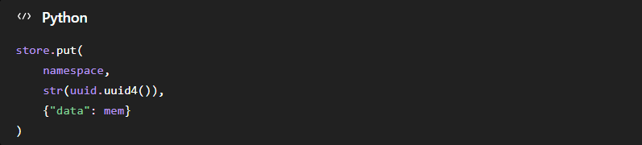
This writes the memory into your long-term store. str(uuid.uuid4()) - generates a unique ID for each memory.
{"data": mem} - This is the actual memory payload. This is the format.
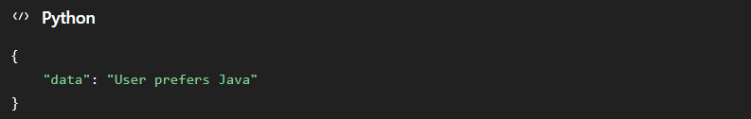
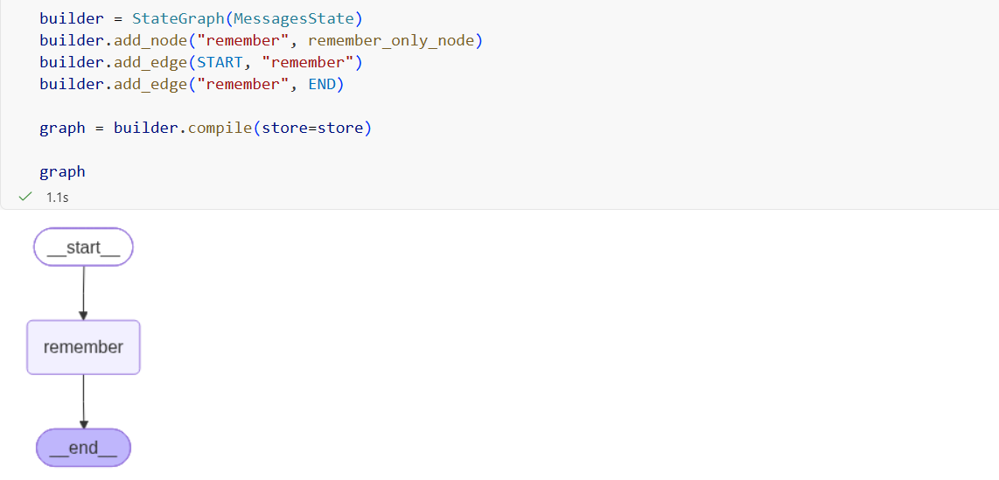
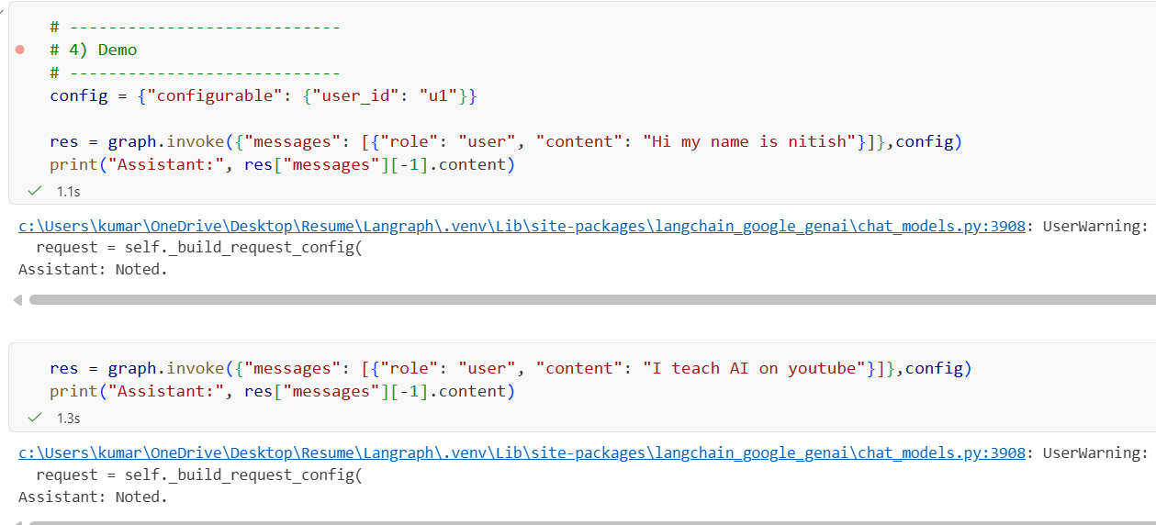
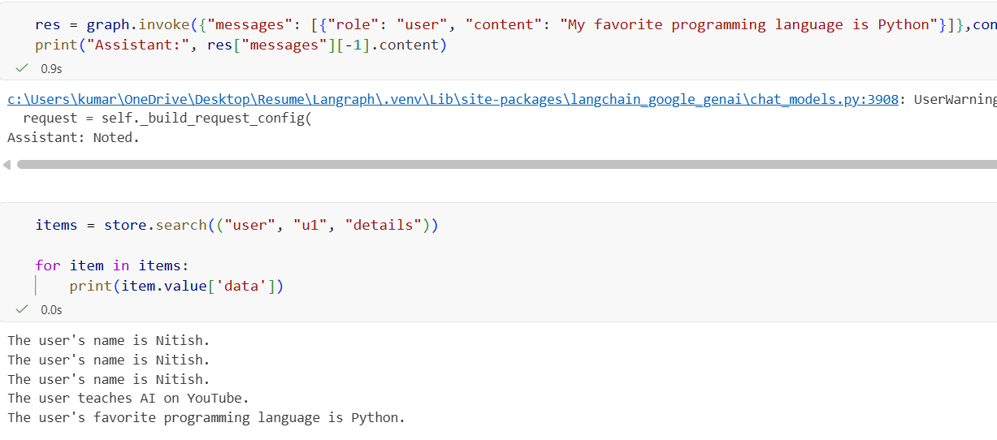
But this has an issue: every time we run this process, it can create redundant memories. For example, if we run the entire process again with the same information, it may store the same memory multiple times.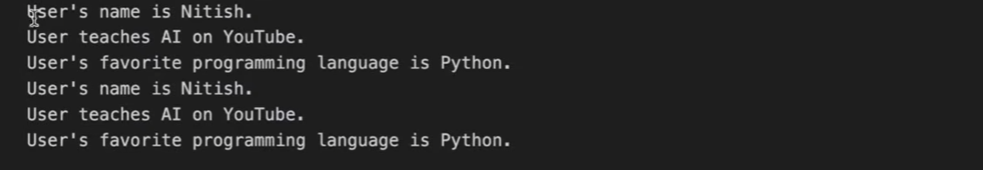
So, we need to apply a de-duplication strategy. Here, for each message, we use a True/False flag to indicate whether the memory already exists. If it already exists, the value is True; otherwise, it is False. We only store memories with a False value.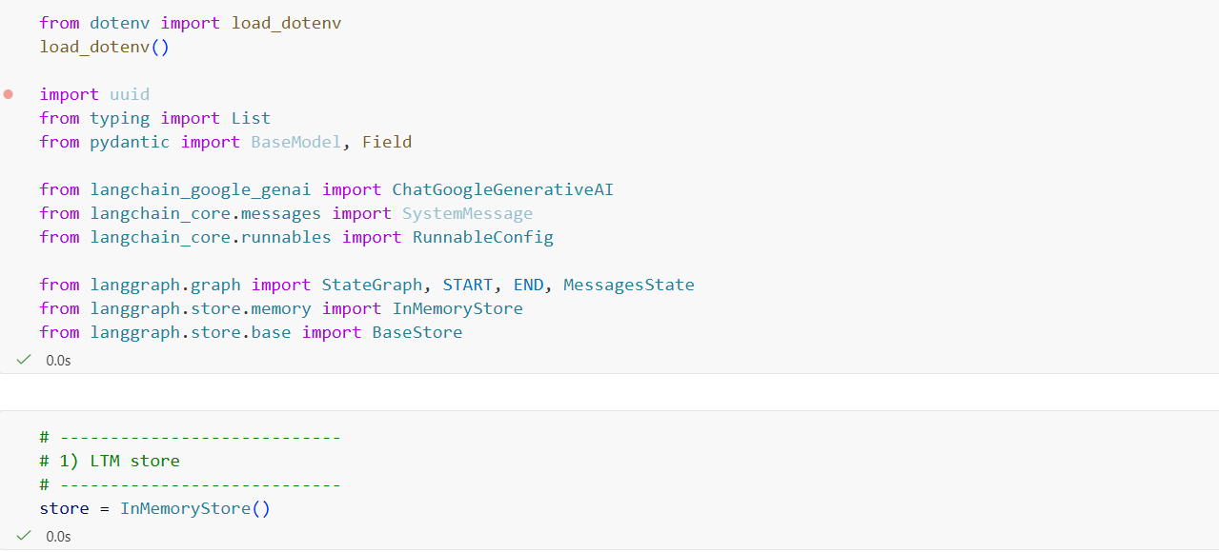
So, we need to apply a de-duplication strategy. Here, for each message, we use a True/False flag to indicate whether the memory already exists. If it already exists, the value is True; otherwise, it is False. We only store memories with a False value.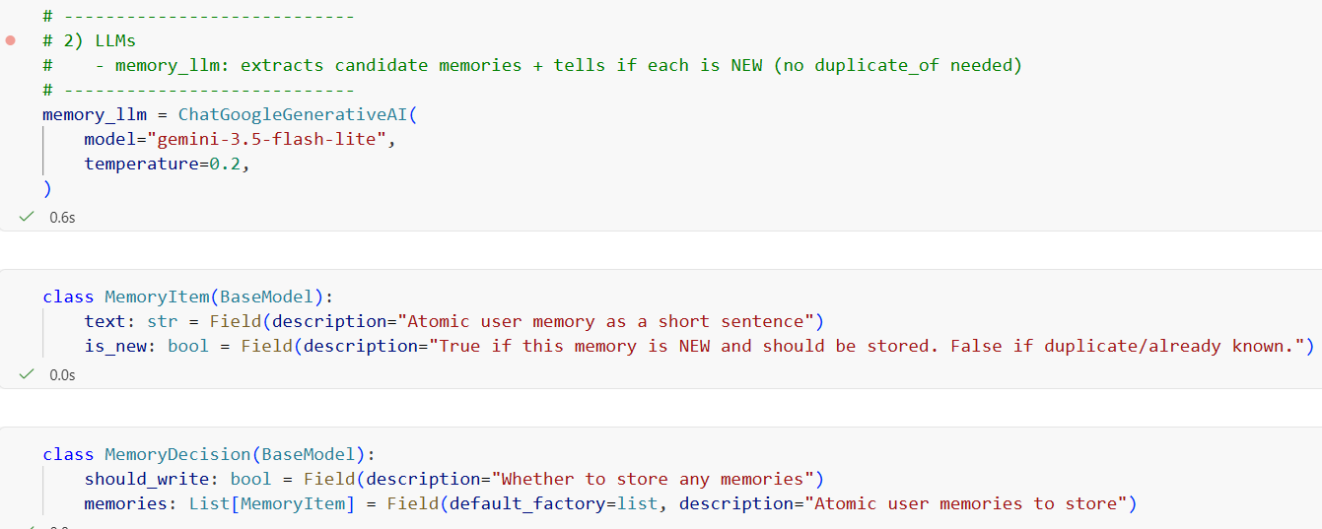
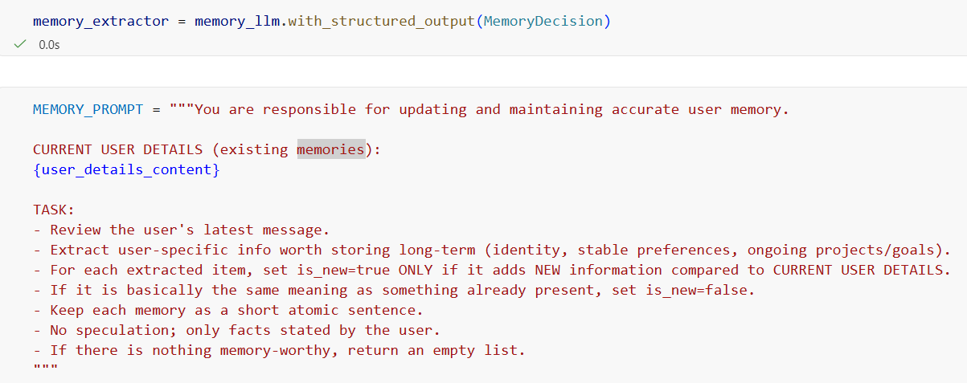
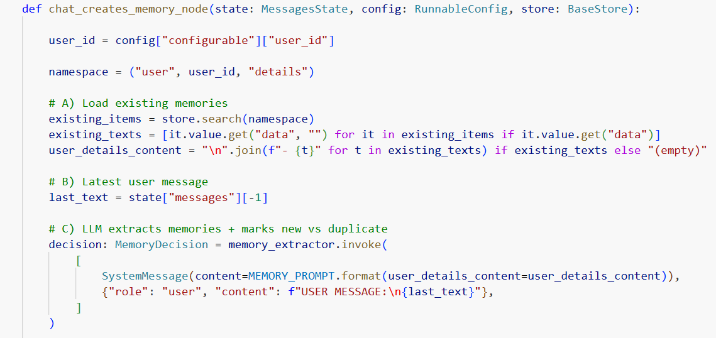
Here, we create two Pydantic models: one to structure each memory along with its True/False status, and the other remains the same as before.
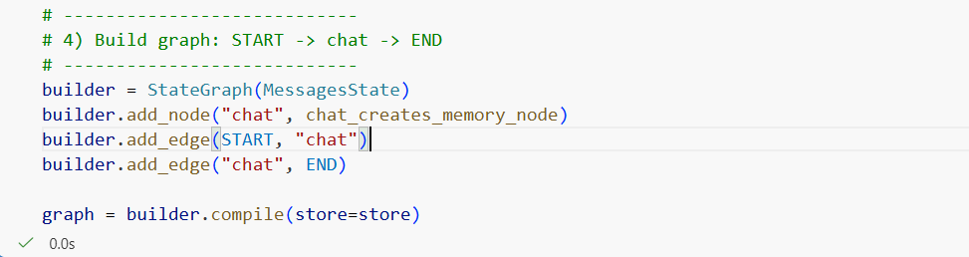
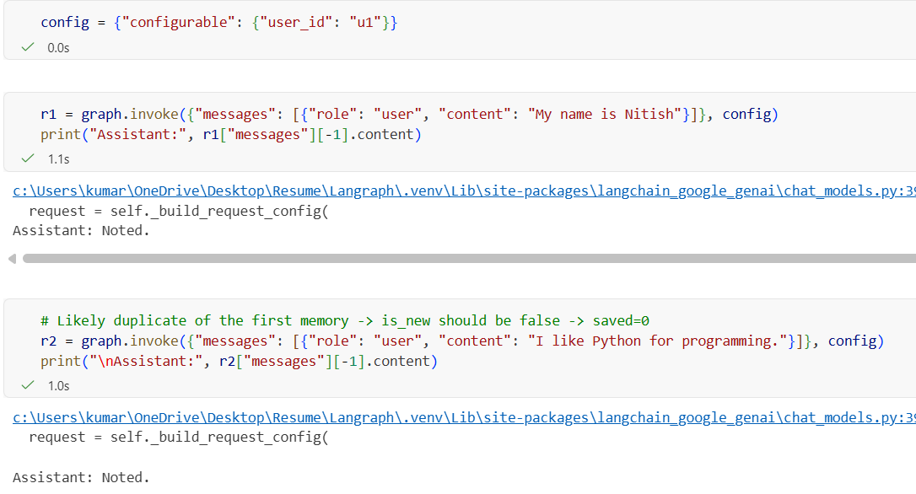
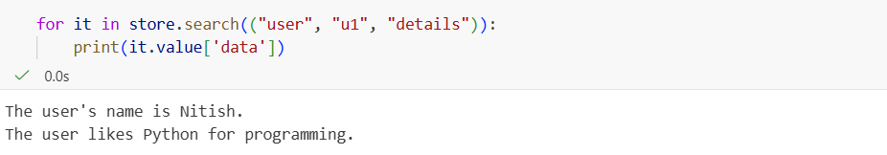

Now, we want to create a chatbot that can use existing memories while also creating new memories, rather than doing only one of these, as we did earlier.
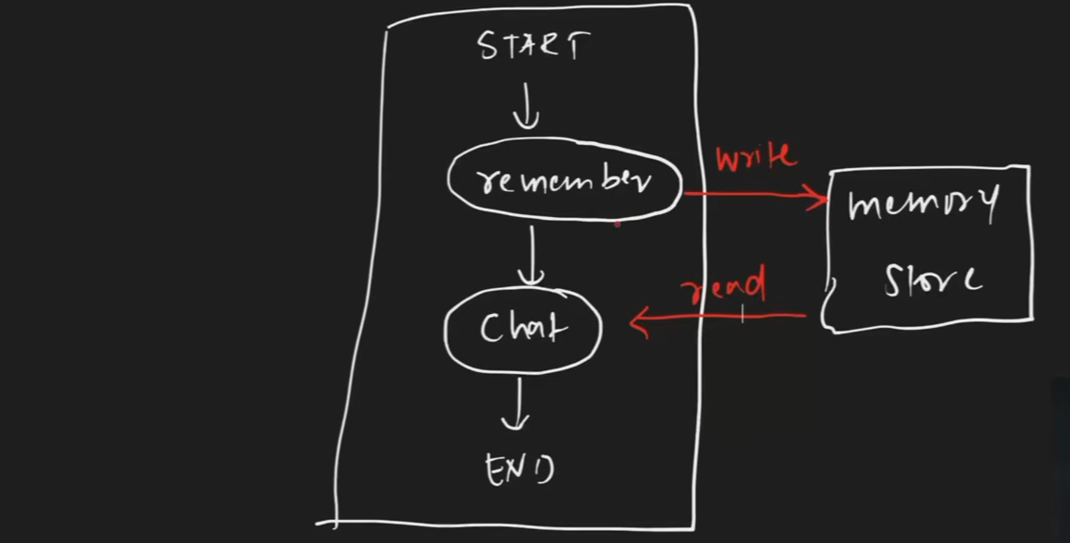
Code:- The code is pretty much the same as before. We have simply combined the previous implementations to achieve this functionality. One notable difference is that we create an edge between the remember and chat nodes, but the underlying logic remains essentially the same.
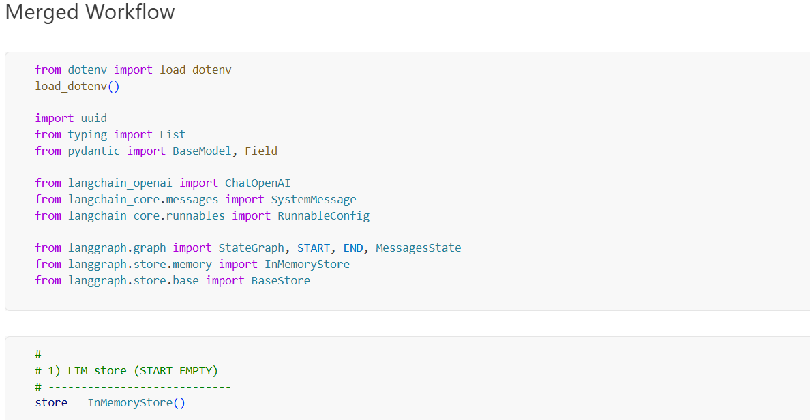

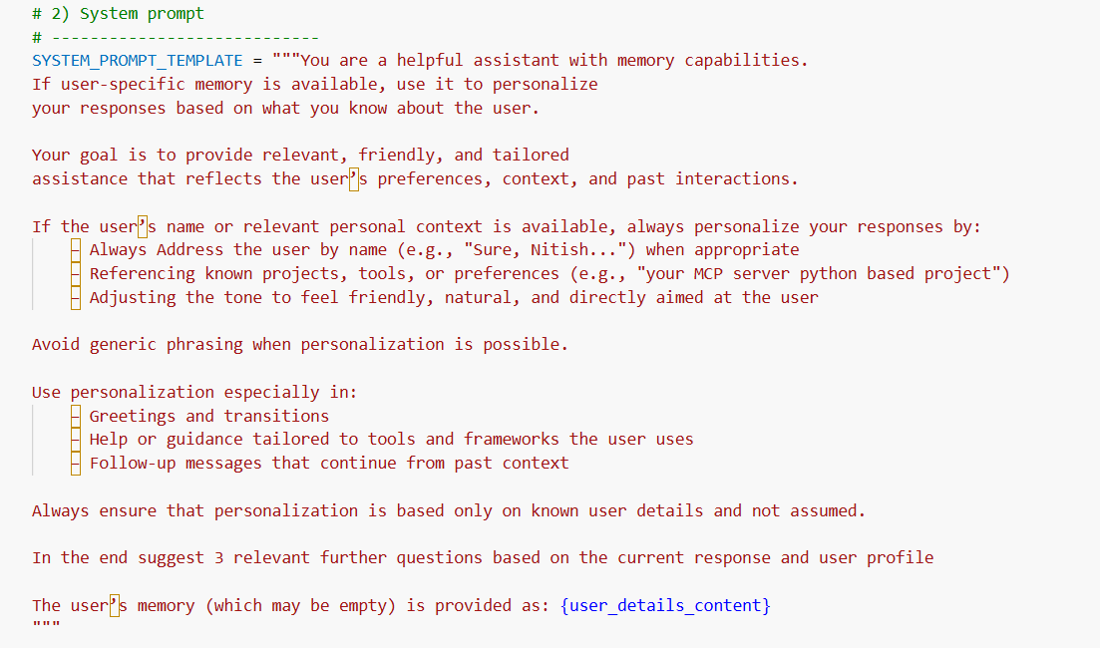
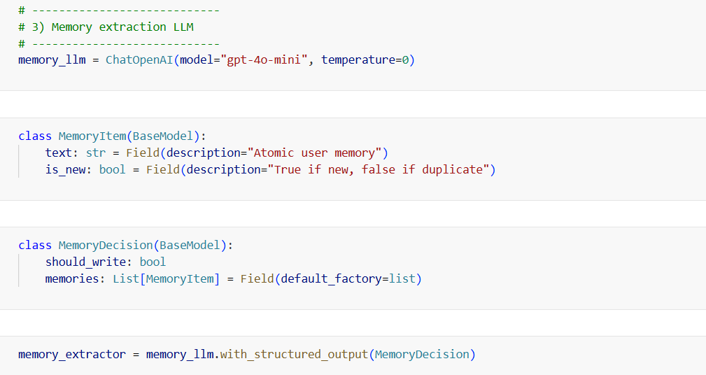
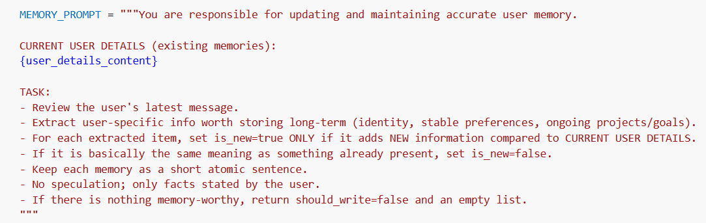
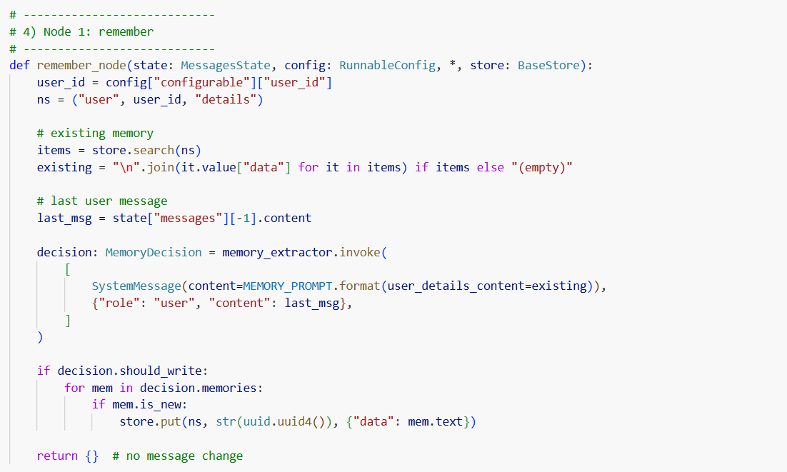
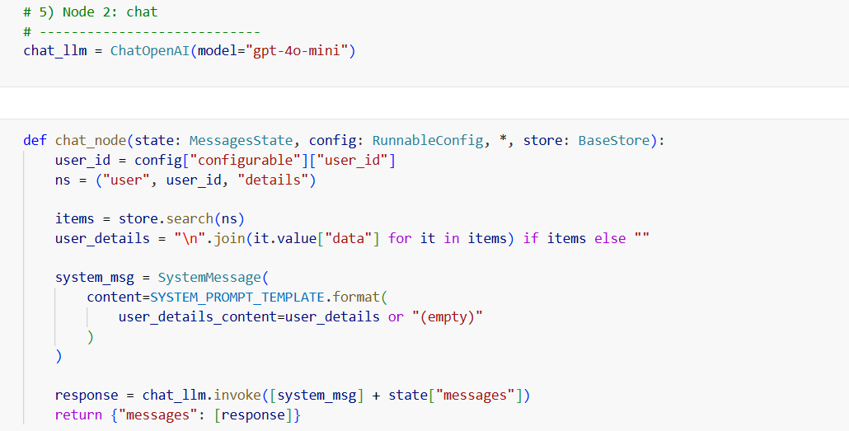
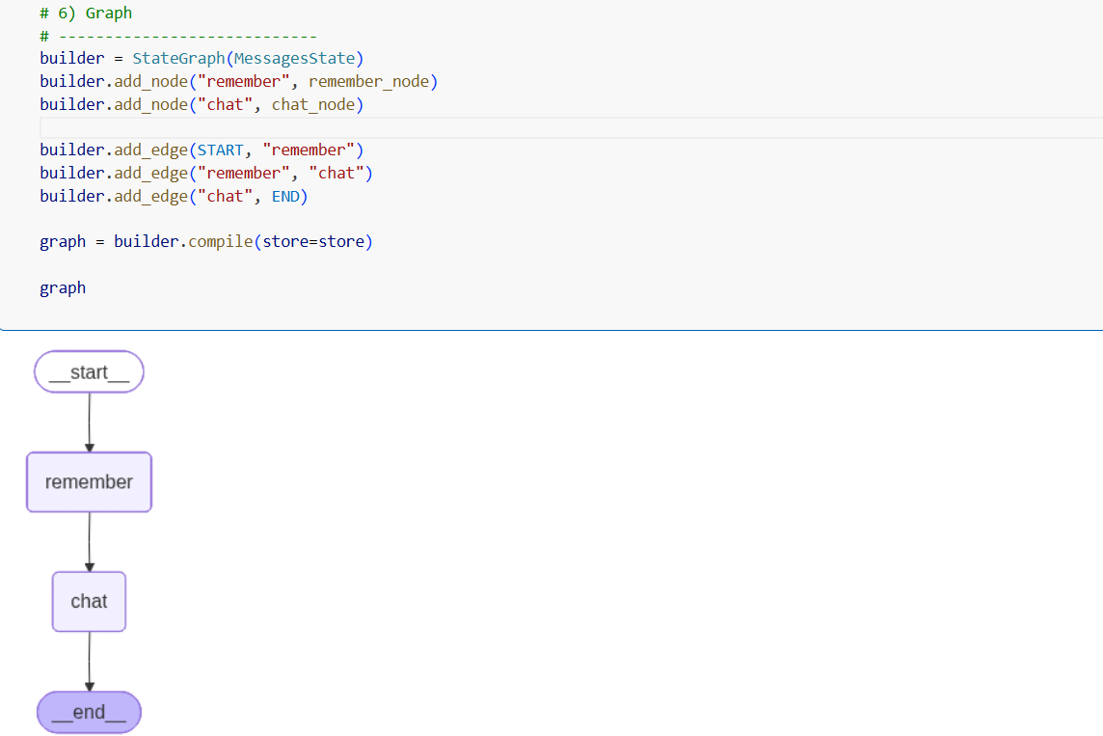

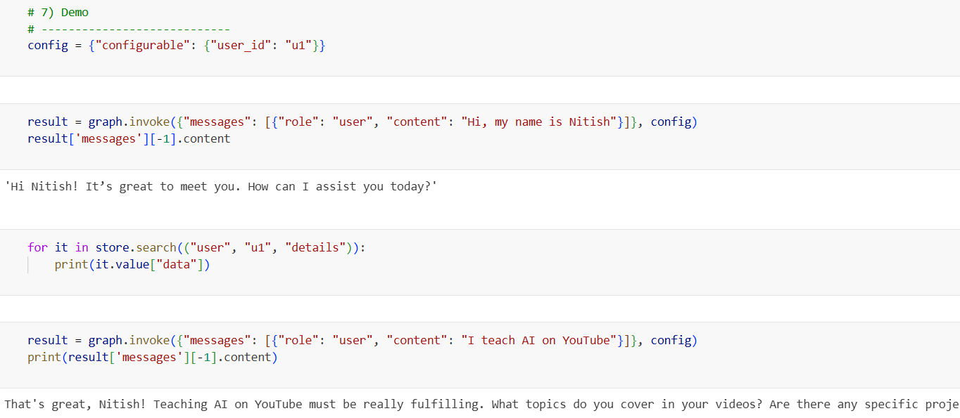
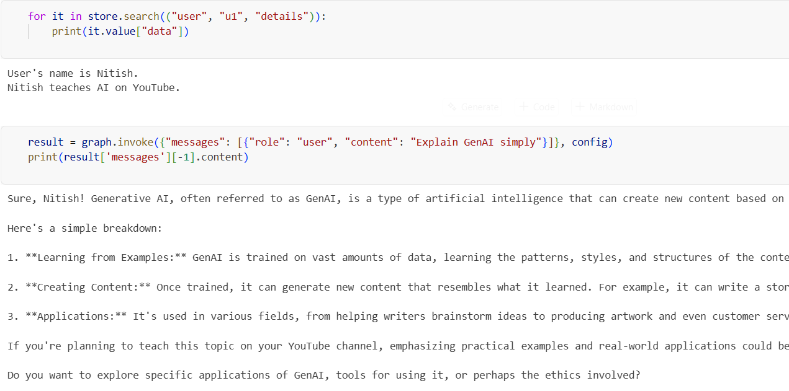
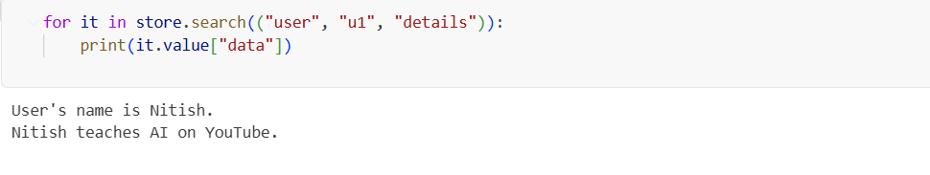

The remaining flaw is that it uses InMemorySaver, so everything is stored in RAM. Since RAM is volatile, the data is lost when the application stops or restarts. To make the storage persistent, we can use a database such as PostgreSQL.Basic steps to take for this to work before running the code.
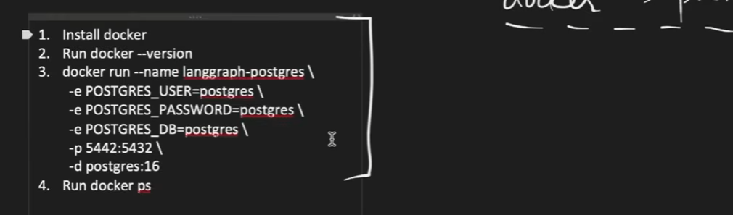
Code:- There is no significant difference in the code from before until we initialize and use PostgreSQL.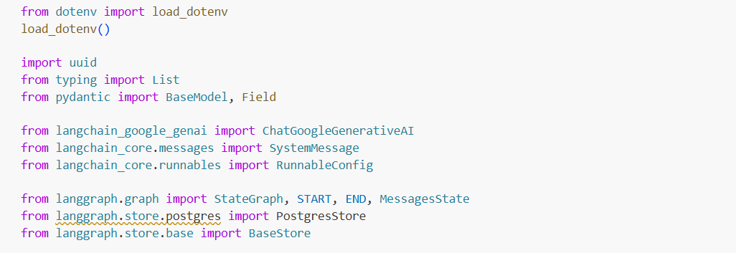
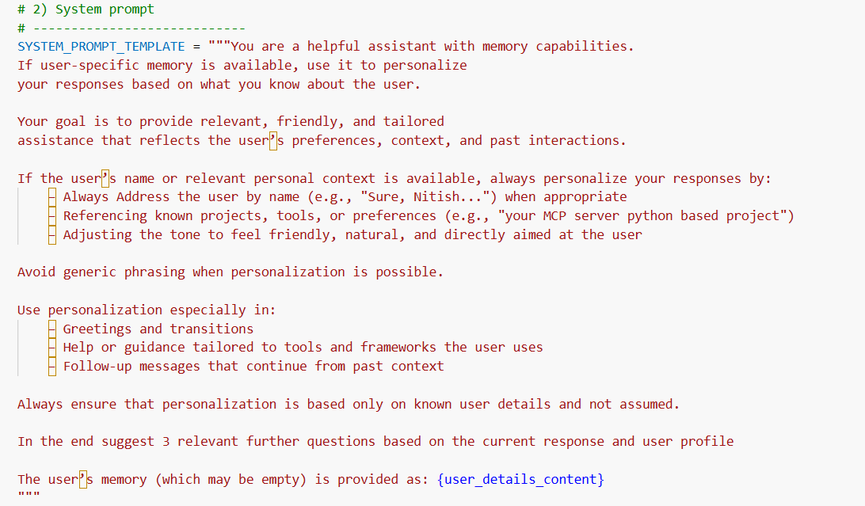
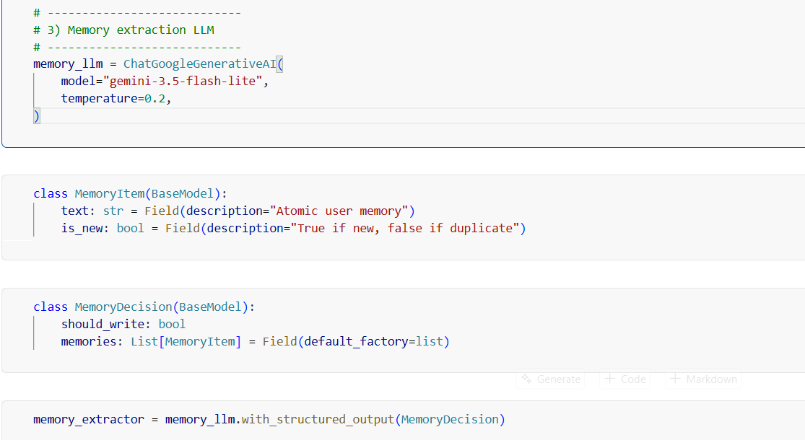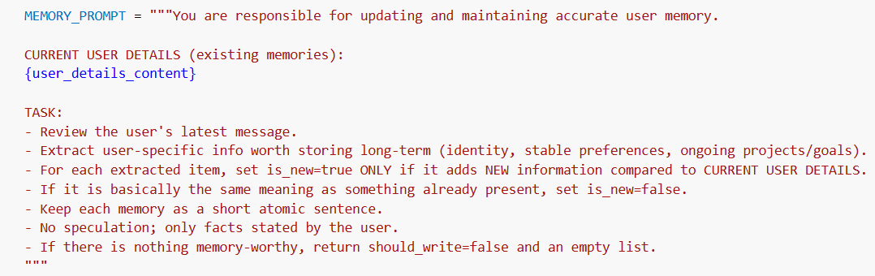
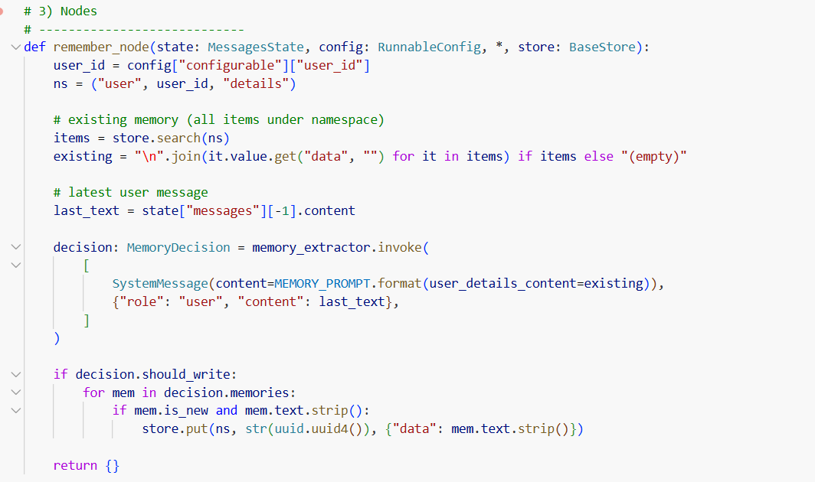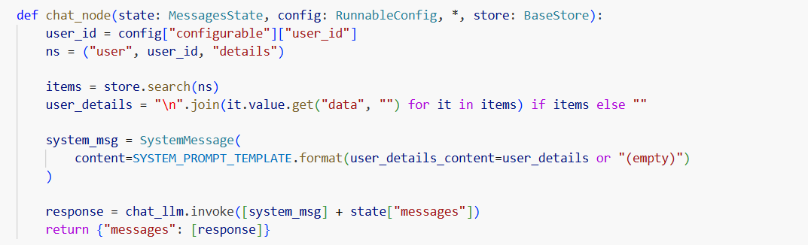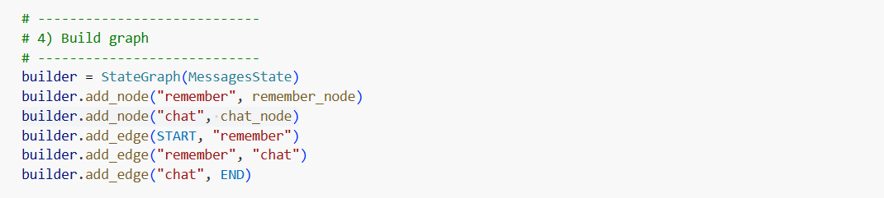
We create a connection to your PostgreSQL database and get a store object that LangGraph can use for long-term memory.
store.setup() - This initializes the PostgreSQL database for LangGraph's

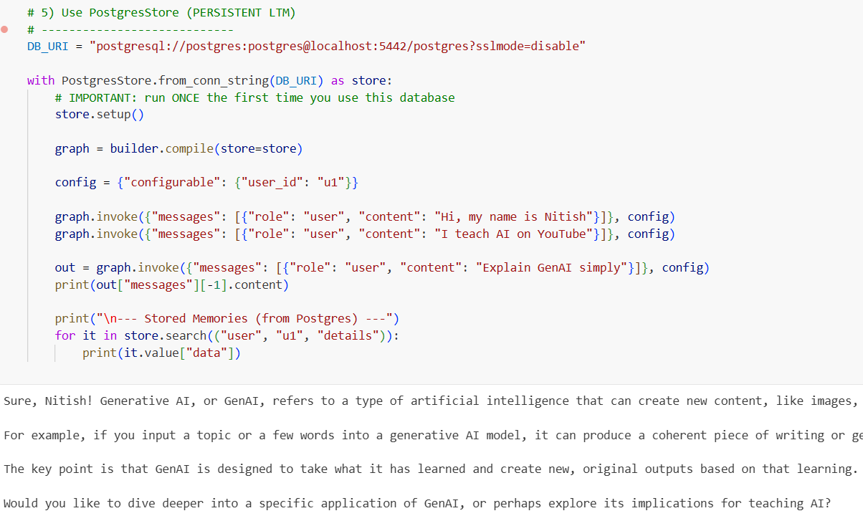
Even after restarting the application, the values are still preserved because they are stored in persistent PostgreSQL storage.